NUnit & Moq Assignment – Week 2

Objectives
This assignment focuses on demonstrating core unit testing techniques using the NUnit framework. You will test methods that return values, handle exceptions, work with void methods, and understand the value of mocking in a loosely coupled system.

Concept Explanations
Unit Testing vs Functional Testing
Unit testing involves testing the smallest testable parts of an application independently (usually functions/methods), ensuring each behaves as expected. Functional testing checks the software system against functional requirements, validating complete features or use cases.
Types of Testing
Common testing types include unit testing, functional testing, automated testing, and performance testing.
Benefits of Automated Testing
Automated tests can be run repeatedly and quickly to validate code changes, catch regressions, and maintain software quality.
Loosely Coupled & Testable Design
Code should not depend tightly on other classes. By using interfaces or abstractions, dependencies like databases or file systems can be easily replaced with mocks for testing.

Code Implementation

CalcLibrary.cs (Class Library Project)
using System;

namespace CalcLibrary
{
public class Calculator
{
private double result;

public double Add(double a, double b)
{
return result = a + b;
}

public double Subtract(double a, double b)
{
return result = a - b;
}

public double Multiply(double a, double b)
{
return result = a * b;
}

public double Divide(double a, double b)
{
if (b == 0)
throw new ArgumentException("Cannot divide by zero");
return result = a / b;
}

public double GetResult => result;

public void AllClear()
{
result = 0;
}
}
}

CalculatorTests.cs (Unit Test Project)
using NUnit.Framework;
using CalcLibrary;
using System;

namespace CalcTests
{
[TestFixture]
public class CalculatorTests
{
Calculator calc;

[SetUp]
public void Setup()
{
calc = new Calculator();
}

[TestCase(5, 3, 2)]
[TestCase(10, 4, 6)]
[TestCase(100, 50, 50)]
public void TestSubtraction(double a, double b, double expected)
{
double result = calc.Subtract(a, b);
Assert.That(result, Is.EqualTo(expected));
}

[TestCase(2, 3, 6)]
[TestCase(5, 0, 0)]
[TestCase(7, 4, 28)]
public void TestMultiplication(double a, double b, double expected)
{
double result = calc.Multiply(a, b);
Assert.That(result, Is.EqualTo(expected));
}

[TestCase(10, 2, 5)]
[TestCase(9, 3, 3)]
public void TestDivision(double a, double b, double expected)
{
double result = calc.Divide(a, b);
Assert.That(result, Is.EqualTo(expected));
}

[Test]
public void TestDivisionByZero()
{
try
{
double result = calc.Divide(10, 0);
Assert.Fail("Division by zero");
}
catch (ArgumentException ex)
{
Assert.That(ex.Message, Is.EqualTo("Cannot divide by zero"));
}
}

[Test]
public void TestAddAndClear()
{
calc.Add(4, 6);
Assert.That(calc.GetResult, Is.EqualTo(10));

calc.AllClear();
Assert.That(calc.GetResult, Is.EqualTo(0));
}
}
}

Output Summary
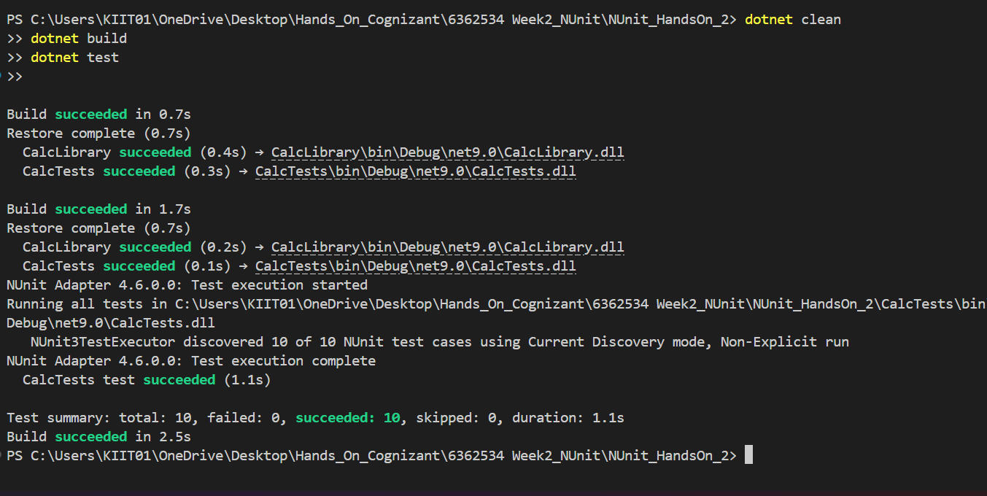

Explanation of Concepts Demonstrated
Parameterized Test Cases
The [TestCase] attribute allows us to define multiple test inputs and expected outputs, reducing repetitive code and increasing coverage.
Testing Methods That Return Values
We used methods like Subtract, Multiply, and Divide, and validated outputs using Assert.That.
Testing Void Methods
The AllClear() method is void. We verify its effect by checking that GetResult is reset to 0.
Testing Methods That Throw Exceptions
The Divide method throws an ArgumentException when the divisor is 0. This is captured and validated using try-catch and Assert.That.
Private Methods
Testing private methods is discouraged because tests should only verify public behavior. If internal behavior must be tested, it likely indicates the need to refactor the logic into smaller public units.
Mocking Framework (Concept)
In real applications, external dependencies like file systems, databases, or APIs should be mocked using libraries like Moq. This ensures tests run quickly and deterministically.

